VYour Non-Negotiable Values



We have covered the CHAIR values - **Courage**, **Humility**, **Initiative**, **Adventure**, and **Resilience** - now, let us talk about some additional set of values.

These are the values that you personally hold as “non-negotiable”. Here are some possibilities to jumpstart your thinking:

**Autonomy/Independence | Self-awareness & Self-management | Growth Mindset | Grit/ Perseverance | Excellence | Creativity | Imagination | Honest | Curiosity | Integrity | Empathy | Emotional Intelligence | Pan-Africanism | Global Citizenship**

Highly successful people are consciously aware of their values, and practice them, even when it is hard. Part of being a thoughtful, conscientious leader is to make sure that you are holding yourself accountable to knowing and living your values, as much as possible throughout your career and lifetime. One way to do this is to be very clear with yourself on what your **personal non-negotiables** are - in other words, what are the values and elements of your life that matter the most to you?

For example, when looking at the list above, which of the values are your top 3? You can think of these things as your **BIG ROCKS**. Let’s unpack this on the next page.

# The Ideal Graduate



Let’s get more specific. As an ALX graduate, not only do we expect you to build a set of character traits and values that are essential for any leader, but we also expect you to use these as the foundation for the rest of your career and your life. To understand what we mean by this, you can think about a tree.

Every tree has four main parts:

* **The roots,** which keep the tree grounded and act as a source of water/life
* **The trunk,** which connects the roots to the rest of the tree and acts as a sturdy foundation
* **The branches,** which allow the tree to grow, flourish and bear fruit
* **The leaves,** which show that the tree is healthy and thriving

**This tree symbolizes you as an individual:**

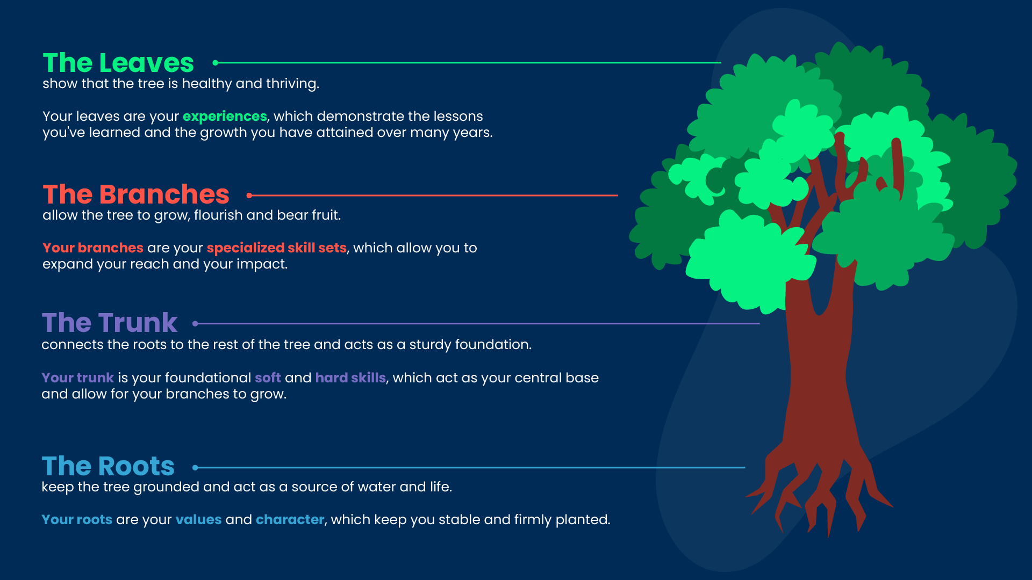

Without roots and a trunk, storms may blow your tree down. Storms can be in the form of challenging life events (e.g. family members passing, getting fired from a job). If your roots and trunk are strong, you can easily grow again regardless of the weather.

On the other hand, without branches and leaves, you would never be able to attract others towards you or share what you have with the rest of your community. With branches and leaves, you can grow to become expansive, and even assist other trees in growing as well.

An ideal ALX graduate recognizes that all parts of their tree are essential to being a change-making leader in the world!

What is your tree made out of? Grab a pen and draw it out! List out what your roots, trunk, branches and leaves are made of. Take a picture of your drawing and share it with your peers on eHub. Check what others are sharing about themselves and their roots!

# PICS

Nope! We are *not talking* about your social media pics, so you can put that camera away :) To understand **our version of PICS**, please read on!

**Self-awareness** is a lifelong journey, and **the “picture of you” in your mind** becomes clearer and clearer as you collect more experiences and continue on your personal journey. But how, then, can you make decisions on the *first steps* of your careers, if you are still uncertain as to what your life paths should be, or what your strong points are?

A **tool** that you can use here to help determine what you like and what you are good at is called **PICS**—Passions, Interests, Causes, and Strengths.

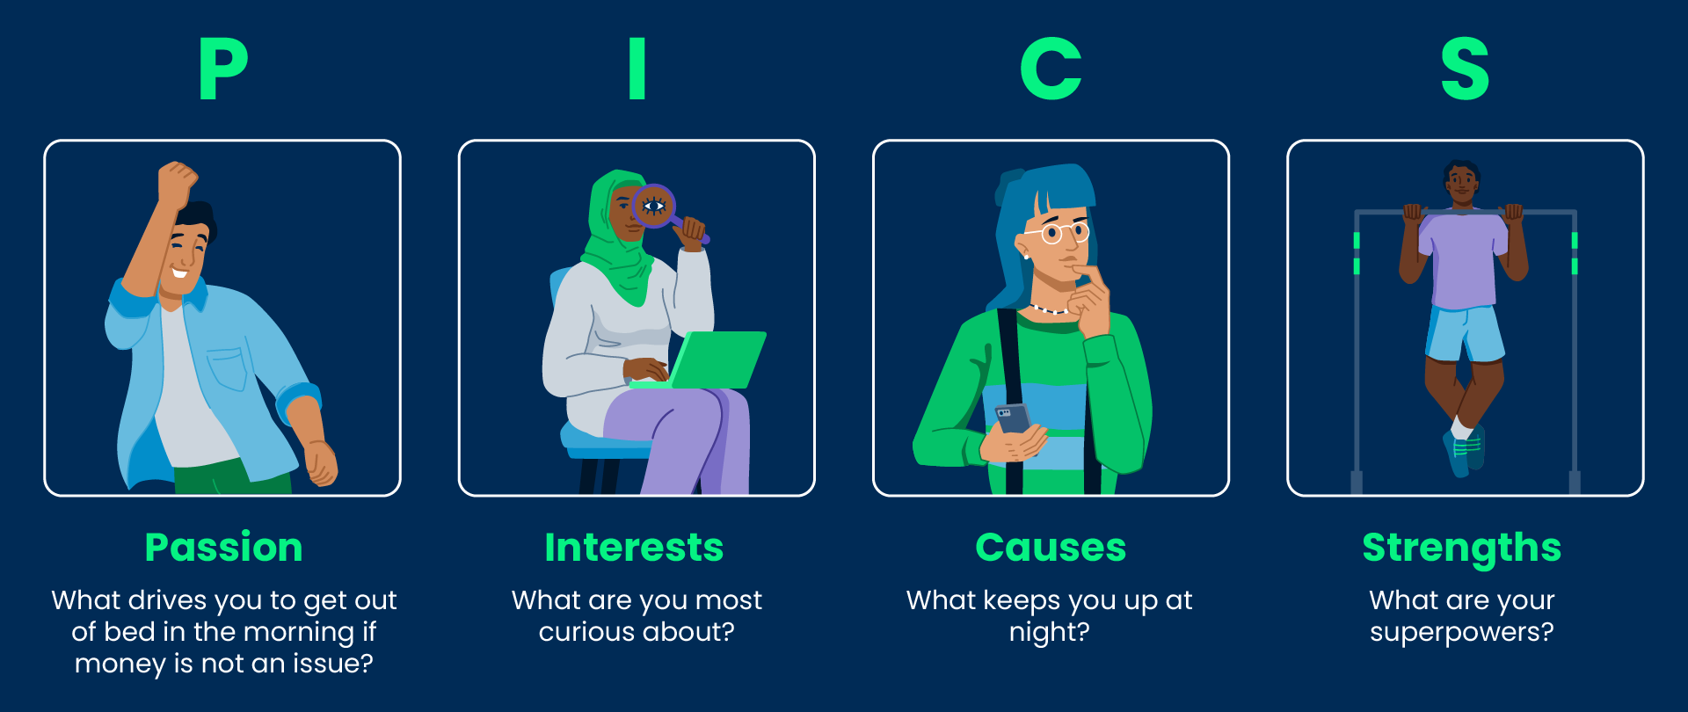

Answering these will help you to **continue to interrogate and evaluate** the path you want to take and the difference you want to make in society as a young leader and change-maker.

**Learn more** about what Passion, Interests, Causes, and Strengths are and how they benefit your personal and professional development by reading the following supplementary articles.

# Individual Activity: PICS



#### THIS ACTIVITY WILL FORM PART OF YOUR WEEK 2 MILESTONE SUBMISSION

**Instructions**

**Now that you know what PICS are, it is time to self-reflect using the following questions:**

* **Passions:** What would you get out of bed for in the morning if money wasn’t an issue?
* **Interests:** What are you most curious about?
* **Causes:** What keeps you up at night?
* **Strengths:** What is your superhero power?

1. You must do your reflection using a personal copy of this [**Worksheet**](https://docs.google.com/document/d/1LIV5m9p9Mo6wxm70CNsYVeWXNlLP-hUMlEMY6r7hSeE/copy) called **PICS** and **Personal Mission Statement** Worksheet. Open the link and follow the prompt to create a personal copy by clicking on the button that says “Create a Copy”.
2. Complete Part A of the worksheet with your PICS.

**1. Schedule some quiet time to just write**

*Do this once a day for a week.*

Maybe this is just for 5 minutes or you get into it and find that you need 30 minutes or more. What is important is that you **make sure** to schedule this time for when you aren’t rushed and **can focus on just this**.

**2. Start with a question**, and write/ type your responses down and save them. You can choose a few of the questions below, or create new ones.

**Great questions** to ask are:

* What’s important to me?
* What do I want my legacy to be?
* What does my ideal day look like?
* Who would I do anything for?
* What am I grateful for?
* When do I feel the calmest?
* What makes me feel powerful?
* What makes me different from other people?
* When do I feel most useful?
* What makes me feel alive?
* What do I wish I made more time to do?
* What am I great at?
* What’s something I haven’t done that I want to do before I die?
* If I had an extra hour each day, how would I fill it?
* Who inspires me? Why?
* Who do I want to inspire? Why?
* What am I most proud of?
* What do I pledge allegiance to (what am I committed to beyond doubt)?
* What am I inspired to be, do and give?

This list **can go on** forever, and your questions **can be as broad or as specific** as you want. The point of this exercise is to **get you to reflect** on *who you are now, who you want to become, and what you’re willing to do to get there*. **Use concrete examples** when you can, and **don’t judge** your own answers.

**3. Repeat step two, by asking yourself the same question again for a few days.**

Do not look at your responses from the previous days, just **answer each question afresh**. Each time, write (or type) your responses down and save them.

# Individual Activity: Writing Your Personal Mission Statement



**Important!**

This activity will form part of your Week 2 Milestone submission.

With all of that preparation behind you, the time has come **for you to write** your Personal Mission Statement!

### Instructions

1. Take a few minutes to **reflect and tie together** all that you’ve learned about PICS and a Personal Mission Statement (PMS). You should attempt to **make connections** between the two.

2. Next, open your already partially completed [**PICS and Personal Mission Statement Worksheet**](https://docs.google.com/document/d/1LIV5m9p9Mo6wxm70CNsYVeWXNlLP-hUMlEMY6r7hSeE/copy), and go to Part 2 of the document.

3. Write your Personal Mission Statement by **completing Sections 1-6** in Part 2 of the worksheet. These sections are about your:

* Personal mission
* Key strengths
* Areas for growth
* Values you want to abide by as a leader
* How your values connect to your mission and to the change you want to make in the world.
* Why you are choosing this mission statement

4. In each of the sections, your responses should be a paragraph narration of **not more than 50-80 words** in length. Please do not use bullet points.

5. When you’re done, please **save your document as PDF**. You will submit it as part of Week 2’s Milestone, and it will also help you create your Week 4 Milestone slide deck.

Guess what! You’ve just **reached a significant milestone** by completing your Personal Mission Statement. Congratulations! Way to go! Allow yourself to meditate on that success for a minute.