# Global Challenges and Global Opportunities

Part of your learning objectives in this course is to **identify your personal mission in society**, as a young professional. In an ever-changing world of work, siloed **academic learning** is quickly losing relevance, unless it is **coupled with a meaningful mission** that **enables you to meaningfully contribute** towards the global narrative.

Please watch this **video** by Fred Swaniker attentively, as he speaks on the importance of connecting your career to a meaningful mission (i.e. the so-called **7 Global (Grand) Challenges** facing the world).

On the other side of the 7 Global (Grand) Challenges that Fred talks about, there are **7 Global (Grand) Opportunities**. These are:

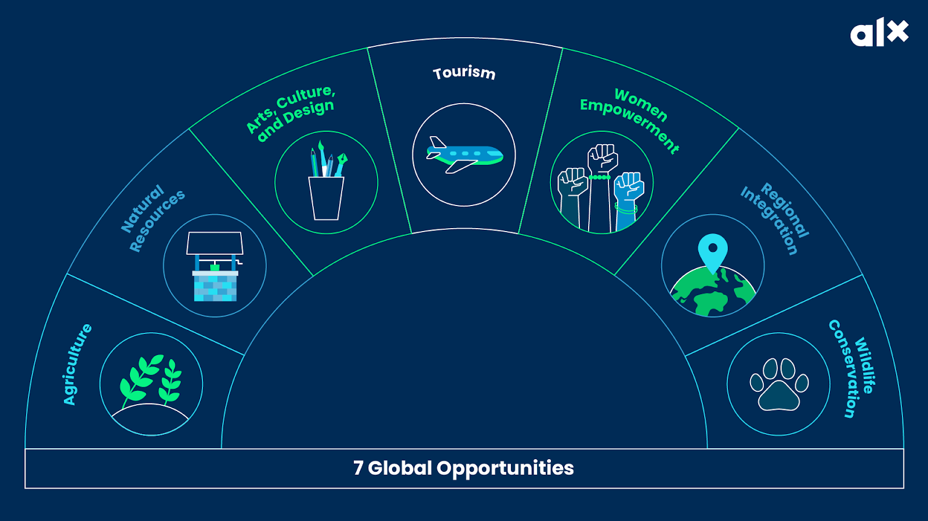

**Reflect:**

We will speak to each of these Global Challenges and Global Opportunities (GCGOs) in the coming weeks. At first glance, without overthinking about it:

* What Global Challenge resonates the most?
* What Global Opportunity resonates the most?
* What seems to connect with areas you are passionate about?
* Is there a connection between any one of the GCGOs and a tech career?

**Share you thoughts** with your squad on the [**eHub**](https://ehub.alxafrica.com/), and see what others are saying!

# Morning Pages



Morning Pages is **Secret Weapon #1** of the Daily 3. A recent graduate emailed us and said, “The morning pages are a hack I never knew I needed.”

**What are Morning Pages?**

Morning Pages were made famous more than 25 years ago in the best-selling book *The Artist’s Way*. But the practice is not just for artists! It’s a life-hack used by many successful business people, entrepreneurs, people who create social impact and, of course, tech talent! Doing morning pages every day has been shown to increase creativity, positive mood, and big-picture thinking for all kinds of people!

BUT, the purpose of Morning Pages is **NOT to produce creative writing.** This is an important point to understand! Rather, writing Morning Pages provides you with the **opportunity to clear out space in your head**, so that your mind is more open to receive inspiration.



### Here are the rules for how Morning Pages work:

* The ideal is to do them first thing when you wake up. But any time of day is OK.
* Get a pen and paper and just start writing (or keep a Morning Pages journal). You *must* do this by hand—don’t type!
* Write down whatever pops into your head. Really, whatever’s there—just write it!
* Don’t stop writing. Don’t re-read what you’ve written. Don’t go back and edit.
* If you don’t know what to write, then write, “I don’t know what to write. Maybe it’s because…” and you’re off again. Just keep the pen moving!
* Write 3 pages.
* When you’re done, put them in an envelope (or burn them). Don’t re-read them! Don’t share them with anyone!
* Remember, the point of Morning Pages is **the *process*, not the product**.

# Mindfulness Meditation



**Secret Weapon #3** of the Daily 3 is Mindfulness Meditation. Over the past 20 years, significant scientific research has demonstrated the benefits of mindfulness meditation:

* Better concentration
* Greater calm and ease
* Better self-awareness

**What is Meditation?**

This practice does not belong to a given culture or religion. It is **simply the practice of relaxing the body** and focusing one’s attention (usually on the breath) to gain a greater awareness of one’s thoughts and feelings. That’s it!

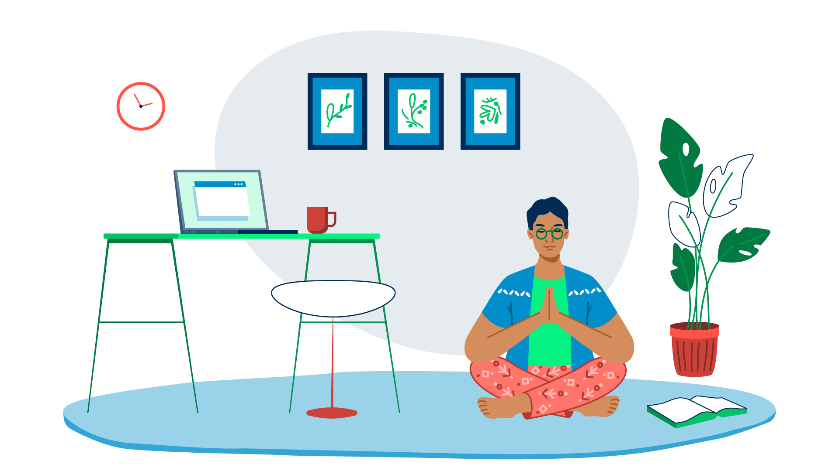

A **common misconception** is that the purpose of mindfulness is **to “clear the mind”** and have no thoughts. But this is not right! **The purpose of mindfulness meditation is to *become more aware* of your thoughts and feelings**. That’s it!

But, as an **added benefit**, it has been shown in hundreds of studies that it does help you **calm your nervous system** and lead to greater creativity, clarity, focus, and insight. Just what a stellar ALX student needs!

Perhaps you’re concerned that you don’t have the time? Don’t worry, **even 1 minute of mindfulness meditation has measurable benefits**! Try taking 2 slow breaths right now and see if you feel calmer.

# Our Values and Code of Conduct

In this module, we’ll share with you our Value and Code of Conduct. As a participant in this course, **you must agree to abide by these guidelines**. Much of this is common sense and courtesy, but it’s important for you to understand specifically **what values we hold** and how we deal with breaches in our Code of Conduct.

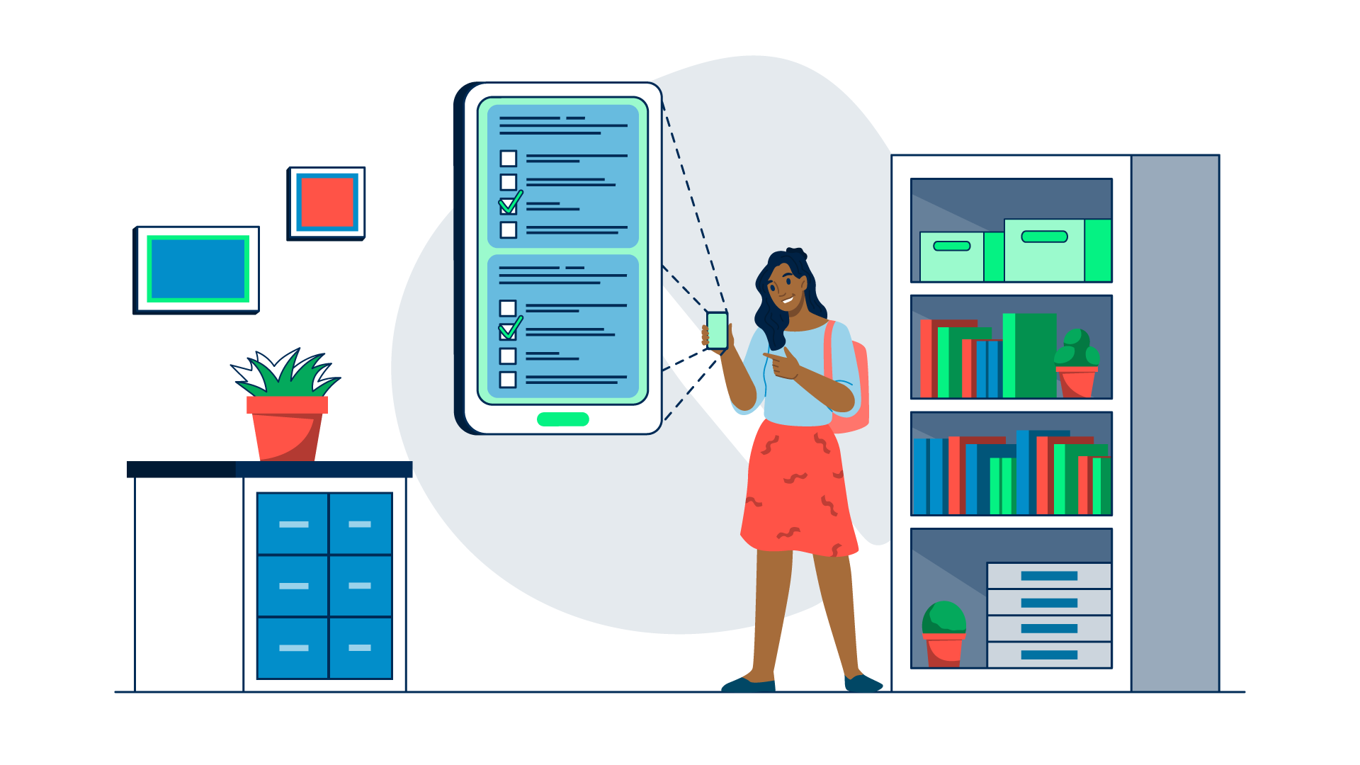

To get going, let’s start with **our pledge**, which is *foundational* for creating a safe space and healthy community.

### Our Pledge

# CHAIR Values



As you’ll remember, **we are big on community**. To ensure that our community is **functioning as it should** be, we are **governed** by a set of values—**CHAIR values**. These are **integral** to us as an organization—our vision and mission.

These CHAIR values **align** with the **Code of Conduct** and the **Honor Code**.

**Let’s unpack** what CHAIR stands for, and on how we can implement each of the values. **Click** on the values in the interactive infographic below to reveal **more information** about them.

Did you catch *why* we call them CHAIR values?

**C - Courage**

**H - Humility**

**A - Adventure**

**I - Initiative**

**R - Resilience**

As you start your learning journey, cultivating these values will **enable you to succeed and thrive** as part of ALX’s community. We will also do our part to help you live up to them as part of this course.

**Reflect:**

* Which value do you find the easiest to practice?
* Which value do you find the hardest to practice and need to become better at?

Think about the questions above, and **share you thoughts** with us and your peers in your squads on the [**eHub.**](https://ehub.alxafrica.com/) Look at what others’ are saying. Don’t just interact with people you agree with, but also **look at other/different perspectives** as well! It’ll help you see things from angles you may not have thought about.



| shaking hands in agreement | We as members, contributors, and leaders pledge to make participation in our community a harassment-free experience for everyone, regardless of age, body size, visible or invisible disability, ethnicity, sex characteristics, gender identity and expression, level of experience, education, socio-economic status, nationality, personal appearance, race, caste, color, religion, or sexual identity and orientation. |
| --- | --- |

# Community Values



We expect you to **uphold** our **Community Values**.

You are now **part of one of the largest, most elite networks of young professionals** on the continent. And **we have expectations** for how you behave in this special community.

Earlier on we shared an abridged version of [**community dos and don'ts**](https://savanna.alxafrica.com/concepts/107590) when interacting on the eHub. Below is a more **comprehensive list** of the values and behaviors we expect from members of our community, both online and offline:

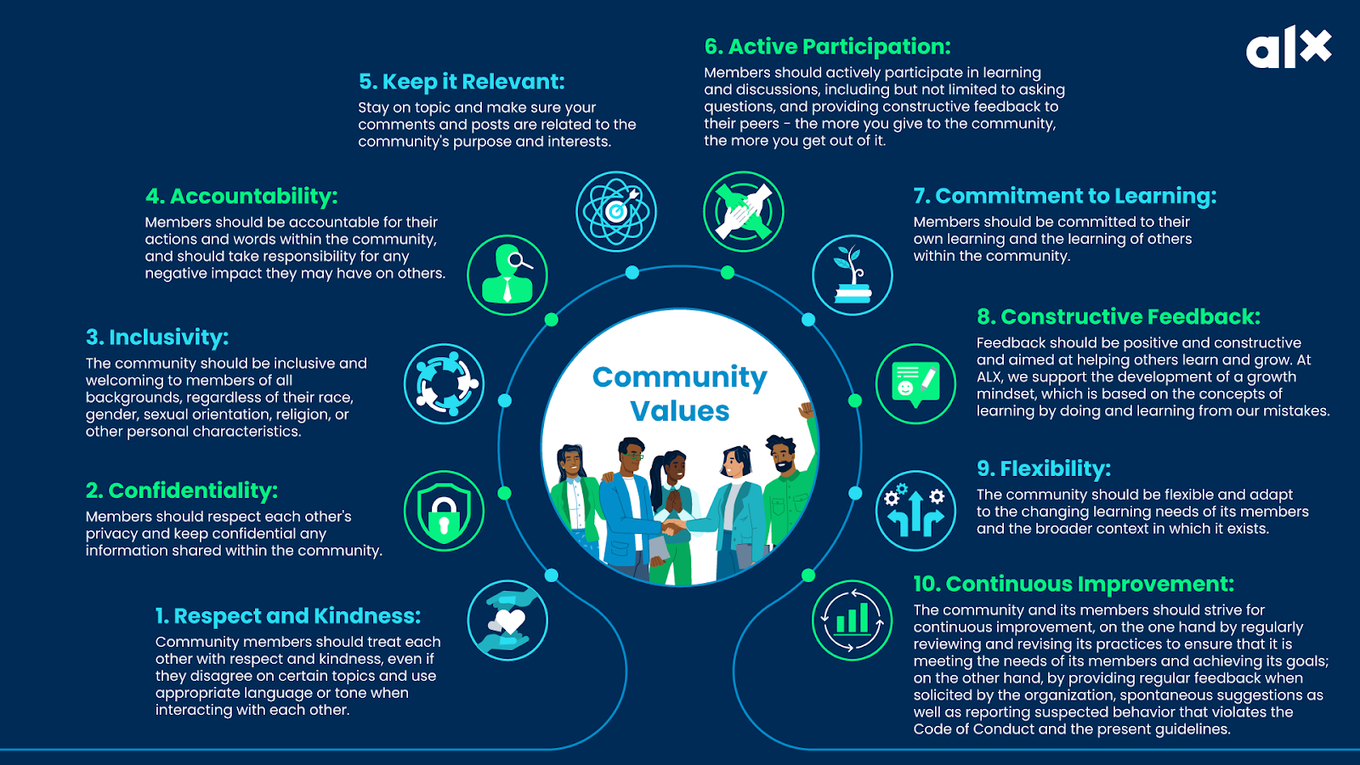

Do any of these feel like they might be **challenging to practice** for you? Why or why not? **Share you thoughts** on the eHub and see what your peers are saying. Focus on discussing ways you can overcome your blockers, and become better at adhering to these values!

# Code of Conduct



We want our community to **provide a secure and inclusive environment for all participants**, where they can **learn and interact freely** without experiencing any form of discrimination, harassment, or intellectual property violations.

**In order to *retain* your access** to the community platforms and City Hubs, you **must agree** to the **Code of Conduct**, which applies to ***all online and in-person*** community activities, and to all one-on-one communications with staff and your peers.

In short, the **Code of Conduct requires** you to:

* Practice CHAIR Values and Community Values to the best of your ability.
* Refrain from:
  + Harassment
  + Discrimination
  + Plagiarism
  + Cheating
  + Any other hurtful or unethical behavior
* Do everything you can to uphold privacy and protect data.

Please **read through** our **official online and in-person guidelines** below carefully.



#### General Principles:

* **Plagiarism:** We take the integrity and authenticity of our learners’ work very seriously. Do not copy or plagiarize internet content, or the work of your classmates. For content submitted with data from the internet, always reference your sources, and ensure that your content is organic. Should you use AI to produce material, be sure to reference it.
* **Be aware of cultural differences:** Remember that members of the community may come from different cultures and backgrounds. Be respectful of these differences and avoid making assumptions or generalizations.
* **No spamming or self-promotion:** Do not post promotional content or spam messages. Posting relevant links or content is acceptable, as long as it is not excessive or aggressive.
* **Keep it legal:** Do not post any content that is illegal, promotes illegal activity, or violates any laws.
* Digital inclusivity: We believe that everyone has the right to a safe and respectful online environment, free from cyberbullying and other forms of digital abuse.
* **Use of AI for good:** As AI becomes increasingly present in our daily lives, commit to finding ways that can help you and your peers improve your workflow.

| Dos: **•** Update your profile on the eHub: Name (please be sure to use your name and surname), profile picture (please use a picture of yourself, not an avatar, a cartoon, or a symbol).  **•** Be nice and friendly to everyone, and report any inappropriate behavior. Respect the code of conduct when addressing others. Please check the purpose of the channel you are posting on. You will be asked to repost if you are on the wrong channel.  **•** Post content that is aligned with our community values and expected behavior.  **•** When communicating with AL staff, clearly state the message’s objective and what you need.  **•** Practice patience when requesting support from AL staff and your peers.  **•** Practice generosity and sharing your time and attention with the team. | Don’ts: **•** Plagiarizing assignments or milestones, whether from the internet, peers, or past learners.  **•** Publishing private information, such as a physical or email address, without their explicit permission.  **•** Perpetrate any public or private harassment, including but not limited to, posting or sending sexual content.  **•** Trolling, insulting, or derogatory comments, and personal or political attacks.  **•** Using channels as DMs—If you have to contact one person in particular, or if you want to send greetings, it is better to bring the conversation into a private space, using DMs.  **•** Impersonate another member (by using the same nickname and picture).  **•** Spam or troll other members.  **•** Post any links to copyrighted material.  **•** Post unrelated content to the purpose of the channel—Remember to check the channel description to know if your post would be pertinent.  **•** Share WhatsApp or Telegram group links.  **•** Ask for project reviews without an appropriate description (e.g. posting the link only).  **•** Share resources, or any type of links, without appropriate context.  **•** Any other conduct which could reasonably be considered inappropriate in a professional setting. |
| --- | --- |



#### General Principles:

* **Respect other participants:** Treat others the way you want to be treated. Be respectful and courteous towards your fellow members, their work, and their space.
* **Keep it clean and tidy:** Clean up after yourself, keep your workspace clean and tidy, and leave communal spaces the way you found them.
* **Be mindful of noise levels:** Hubs can be noisy, but be aware of your surroundings and keep noise to a minimum when necessary.
* **Use common areas wisely:** Hubs have common areas that are meant to be shared by all members. Be mindful of others and don’t monopolize these spaces.
* **Follow the house rules:** Each Hub space has its own set of rules. Make sure you understand and follow these rules to maintain a peaceful and harmonious environment.
* **Don’t interrupt other members’ work:** Hubs are meant to be a productive environment.
* **Be considerate** of others and avoid interrupting their work unless absolutely necessary.
* **Respect confidentiality:** Many members of Hubs work on sensitive projects. Respect their privacy and keep confidential information private.
* **Be collaborative:** Hubs are meant to foster collaboration and creativity. Be open to working with others and sharing ideas.
* **Keep your workspace secure:** Keep your personal belongings secure and don’t leave valuable items unattended.
* **Have fun:** Hubs are meant to be enjoyable and inspiring places to work. Have fun and enjoy the community!

| Dos: **•** Attend community events on time.  **•** Meet and interact with your peers in a respectful manner.  **•** Being kind to others.  **•** Behave professionally.  **•** Respect the dress code (if specified for a certain event): In general, dress adequately for a work environment.  **•** Use welcoming and inclusive language.  **•** Be respectful of differing viewpoints and experiences.  **•** Allow the facilitators to moderate the conversation flow so that we can get through all the questions within the time allotted for discussion.  **•** In case of conflict, seek to resolve the situation respectfully and privately. | Don’ts: **•** Perpetrate or threaten physical harm against other people.  **•** Perpetrate harassment, including but not limited to:   * Verbal comments that reinforce social structures of domination (related to gender, gender identity and expression, sexual orientation, disability, physical appearance, body size, race, age, religion, [your specific concern here]). * Sexual language and imagery, including talks. * Deliberate intimidation, stalking, or following. * Harassing photography or recording. * Inappropriate physical contact. * Unwelcome physical contact or sexual attention. * Advocating for, or encouraging, any of the above behavior.   **•** Disrupt talks, events, or other activities.  **•** Use violent language directed against another person.  **•** Advocating for, or encouraging, any of the above behaviors.  **•** Sign-up for an event in a Hub and not attend: In-person, blended, and live-streaming events will foresee a close number of participants, for logistical reasons. For this reason, if you are unsure whether you will be able to attend, please refrain from subscribing to the event, thus avoiding the risk of denying other participants the opportunity. If, for any reason, you are no longer able to attend, you will be able to unsubscribe from the event via Circle. |
| --- | --- |

**Optional:** If you are still curious to learn more, you are welcome to go and read further on the [**eHub Terms and Conditions**](https://www.alxafrica.com/terms-conditions-portal/).

After reading all of the above, **what is your understanding** of the code of conduct? At it’s very core, what the code of conduct trying to achieve and why do you think that’s important? **Share you thoughts** on the eHub and see what others are saying!

# Harassment

 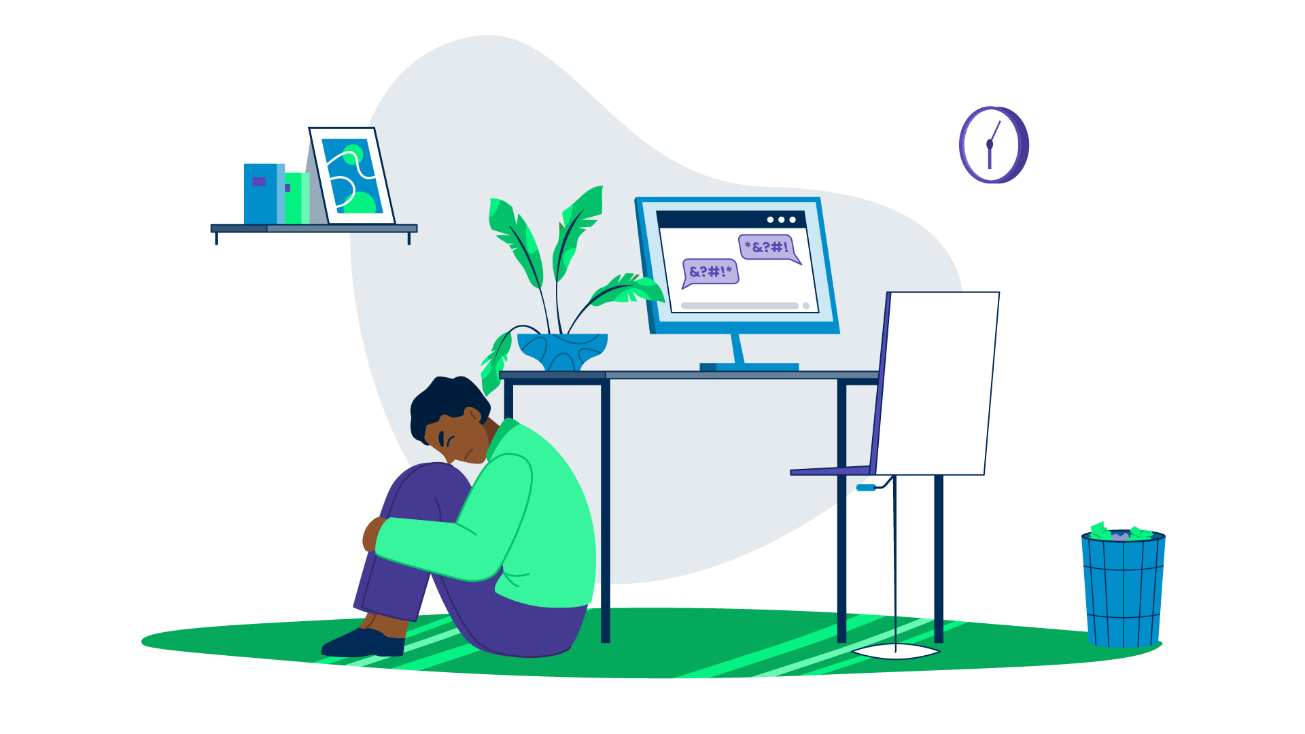

**What is harassment?**

Harassment is **behavior** towards a person that **causes mental or emotional suffering**, which includes repeated unwanted contact without a reasonable purpose, insults, threats, unwanted touching, or offensive language.

### Types of harassment:

* **Verbal harassment:** Calling, or referring to, a person with intimidating, threatening, and/or diminishing language. Example: You call another student names, insult or make inappropriate comments to them or their loved ones, regardless of the reason.
* **Physical harassment:** Addressing a person in physically abusive ways. Example: You push, punch, or slap a fellow participant.
* **Power harassment:** Intimidating, threatening, and/or diminishing behavior coming from a person who takes advantage of their position against the victim. Example: A community manager or any university staff insults you, knowing that you are a student and will probably not take action.
* **Psychological harassment:** A mix of behaviors that makes the victim feel belittled, ashamed, or dismissed, and affects their mental health. Example: You bully a student in such a way that they don’t feel like coming to the City Hub anymore, or they stop engaging on the online community platform.
* **Cyberbullying:** Behaviors that happen on, or leverage, technology. Example: You share the personal info of a student with others, or you insult other students online.
* **Retaliation harassment:** A mix of behaviors aimed at taking revenge on the victim for something they have done. Example: You receive a review from a peer that you think is too low, and you take revenge on them.
* **Sexual harassment:** A mix of behaviors that imply sexual references. Sometimes it can take the form of a “tit for tat” type of exchange. Example: You make sexual comments to a fellow participant or university staff, and send sexual content. Or, you ask for sexual favors in exchange for the solution to a quiz or a good review.
* **Doxing:** Publishing or distributing someone’s private or personal information, such as their address, phone number, or workplace, without their consent.
* **Online grooming:** Building an emotional connection with someone over the internet for the purpose of exploitation, often leading to harassment, manipulation, or coercion.
* **Trolling:** Purposefully provoking or harassing others online by posting inflammatory or offensive content, often with the intent to disrupt discussions or incite negative reactions.
* **Stalking:** Engaging in persistent and unwanted attention or surveillance towards someone, often causing fear, anxiety, and invasion of privacy.
* **Invasion of privacy:** Violating someone’s personal boundaries—such as secretly recording or taking pictures of them—without consent, sharing private information, or spreading rumors about their personal life.

As more and more of our lives move online, **online harassment has taken center stage** in the conversation around this topic. In fact, this has been of **special concern in academia**. The **impact** of this online harassment **extends beyond psychological harm**, affecting victims’ work engagement and overall well-being.

Please work through the following reading to **learn more** about the topic *in the context of online academic engagement*. It will help you contextualize the reason why we’re placing so much emphasis on this. You only need to go through the “Abstract” and “Conclusion” segments as a requirement, however if you really want to learn about different types of online harassment and its impact on academic performance, we suggest exploring the “Introduction”, “Method,” and “Discussion” sections as well.

Have you or someone you know ever **been a victim of harassment**? If you’re comfortable **sharing the story**, please do so with your peers on the eHub. It’s important to understand the impact that such behavior can have. Read through what others are sharing and see how harassment has the potential to completely ruin someone’s experience, confidence, and belief in the community.

# Discrimination

 

**What is Discrimination?**

Discrimination is **treating someone unfairly** based on race, ethnicity, gender, sexual orientation, religion, or any other characteristic. This includes verbal or written comments, actions, or behaviors that create a hostile or unwelcoming environment for others.

If you are **not sure** whether your behavior might be discriminatory, it is **best to simply not do it**.

Building on your discussions from the previous page, have you or anyone you now **been a victim of discrimination**? What happened, and how did that make you or the victim feel? **Share you thoughts** on the eHub and look at what the other learners are sharing as well!

# Cheating

 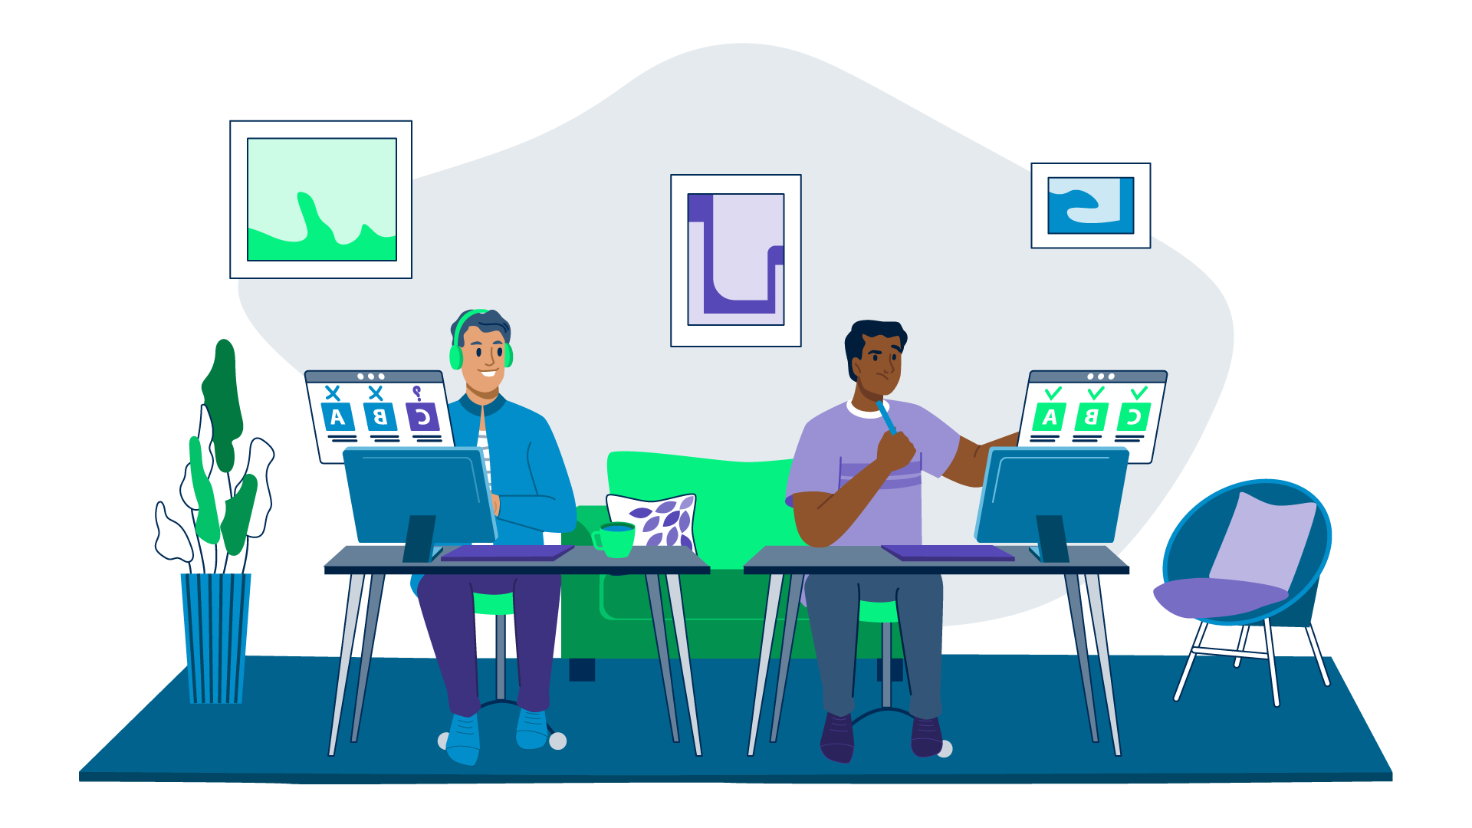

**What is Cheating?**

Cheating is **obtaining, or attempting to obtain credit** for work, or any improvement in evaluation of performance, by any dishonest or deceptive means. This can **include helping someone** else to accomplish the same!

**Cheating** **includes**, but is not limited to:

* Plagiarism
* Lying
* Copying from another’s test
* Taking (or receiving) copies of solutions from someone else
* Using (or displaying) notes when it is not permitted
* Not following the stated guidelines for testing
* Using “cheat sheets”
* Getting information ahead of time that you are not supposed to have
* Allowing someone to do your work for you/pretend they are you

# Please DON'T Cheat!



**Every week, we *randomly* select** Milestones, or other submissions, to be **run through a plagiarism checker** to find students who copied from one another. Unfortunately, it happens more often than you think, and **these students are usually expelled** from the program and express deep regret.

**Copying is just a terrible idea!** You **rob yourself** of the learning and growth experience. You must **commit to putting in the work** that is required to learn.

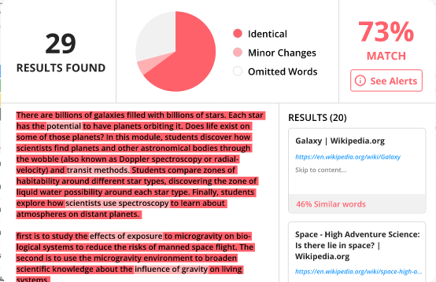

We understand that **the learning journey is not a walk in the park** that is **why we value building communities** that can support you whenever you feel stuck. This is your moment, this is **your chance to learn and explore** new things no matter how complex they might seem. Do not let that chance go to waste, you might never get it back.

**Do Honest Work. Don’t Cheat!**

Why do you think it’s **important to be honest and not cheat** your way through? What could be the harm of cheating, even if you don’t get caught? How does cheating affect the goal that you set for yourself to achieve out of this course? **Share you thoughts** on the eHub and react to what others are saying.

# Privacy and Data Protection

 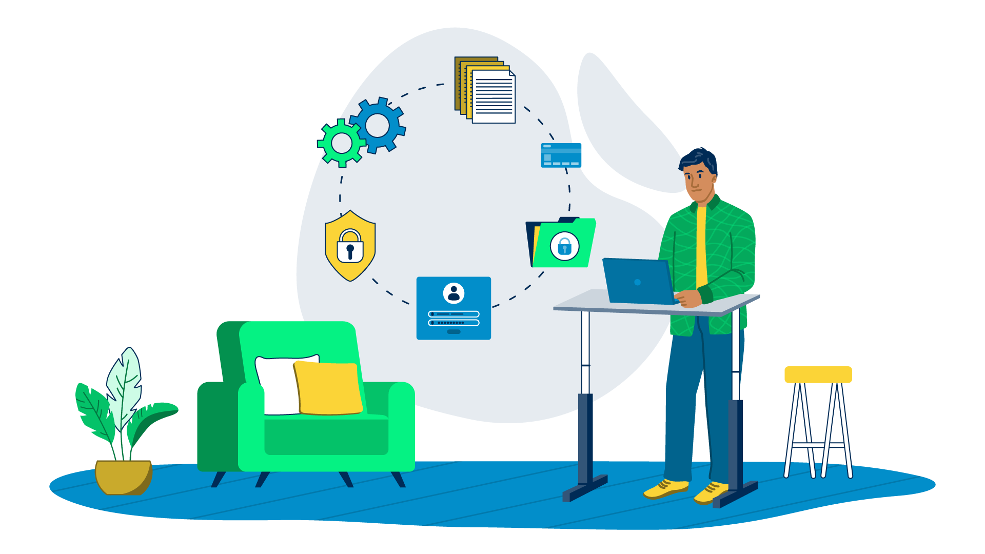

To help **keep our community safe and thriving**, we have **policies** to help ensure the security and confidentiality of our personal information in the digital world. Think of privacy as a personal boundary. It’s about **having control** over information about ourselves and who has access to it. Just like we wouldn’t want strangers peeking into our homes or invading our personal lives, privacy in the digital realm means protecting sensitive information, such as our names, addresses, contact details, financial data, and online activities.

### How we maintain privacy and confidentiality in our community:

Practicing privacy and confidentiality within a community **involves respecting and safeguarding the personal information shared** by community members.

These are the **ways we uphold privacy** at our institute:

* **Obtain consent before sharing:** We seek permission from individuals before sharing their personal information, stories, or experiences with others. We obtain their clear, informed consent, and ensure they are comfortable with the extent of sharing. When in doubt, we don’t share their information.
* **Maintain confidentiality in discussions:** If the community engages in discussions or activities that involve personal information sharing, we emphasize the importance of confidentiality. We encourage all members to keep shared information to themselves, and refrain from sharing it outside the community without explicit permission.
* **Use secure communication channels:** We are cautious about sharing any financial or personal information. If we must share such details (for example to enable a payment to us), we make sure that the communication channel uses proper security protocols.

# Offense Types



We place **violations** of the Code of Conduct into **3 categories**.

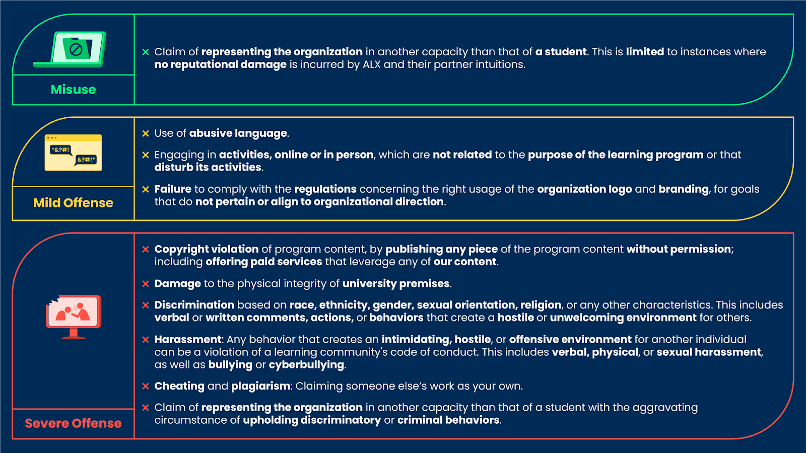



# The Consequences of a Breach



This graphic **provides a visual of the consequences** for a breach of the **Code of Conduct**.

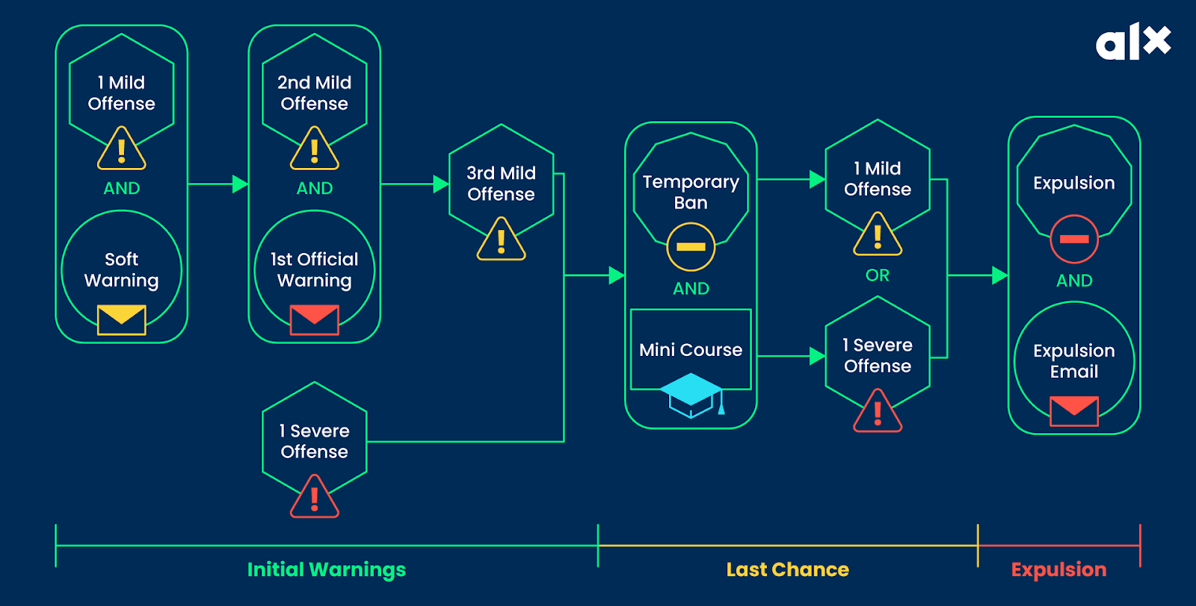

In **summary**:

* If a learner commits a misuse, they receive a soft warning.
* The *first* time a learner commits a mild offense, they receive a soft warning.
* The *second* time a learner commits a mild offense, they receive an official warning.
* If a learner commits ***3 mild offenses*** OR ***1 severe offense***, then they will be temporarily banned from the program and required to complete a mini-course before being allowed re-entry.
* Any subsequent offense, after the completion of the mini-course, will result in expulsion (i.e. permanent ban from all university programs).

**Important!**

Any **offense deemed severe enough** can result in **immediate expulsion**.